DEBUGGER LOGGING:

<https://stackoverflow.com/questions/35038242/asp-net-5-core-rc1-how-to-log-to-file-rolling-file-logging-dnx-core-5-comp>

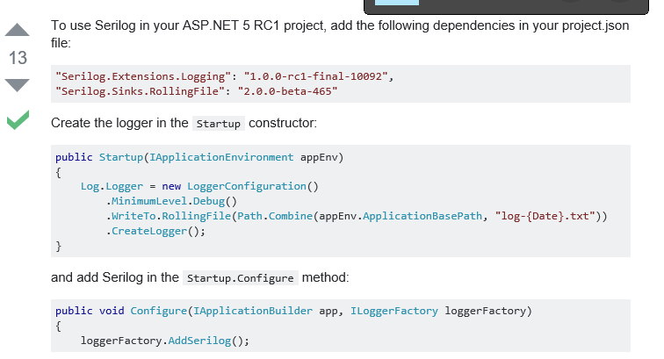

My CODE:

//https://stackoverflow.com/questions/35038242/asp-net-5-core-rc1-how-to-log-to-file-rolling-file-logging-dnx-core-5-comp

string File = "logs/log-{Date}.txt";

if (env.IsDevelopment())

{

Log.Logger = new LoggerConfiguration()

.MinimumLevel.Debug()

.WriteTo.RollingFile(Path.Combine(env.WebRootPath, File))

.CreateLogger();

}

else

{

Log.Logger = new LoggerConfiguration()

.MinimumLevel.Information()

.WriteTo.RollingFile(Path.Combine(env.WebRootPath, File))

.CreateLogger();

}

The logfileis auto created.

C:\vwd projects mvc angular\Deltavicore11\Deltavicore11.web_app\wwwroot\logs